**May 2016 SL P1**

**Section A**

1. Outline **one** problem of maintaining legacy systems. [2]

1. Explain what is meant by user acceptance testing. [2]
2. Discuss one advantage and one disadvantage of printed material, when compared to online

support, as a method to provide user documentation. [4]

1. Outline the use of a failover system. [2]
2. Describe the function of the control unit (CU) in the central processing unit (CPU). [2]
3. Describe how the cache memory can speed up the functioning of a processor. [2]
4. Outline one feature of the operating system that needs to be considered when running a

game application. [2]

1. Construct the truth table for the following expression.  
     
    A xor (B or C) [3]

1. In an 8-bit register, state the binary representation of the hexadecimal number 3B. [2]
2. Trace the following fragment, for N=139 and L=3, by copying and completing the trace table given  
   below.

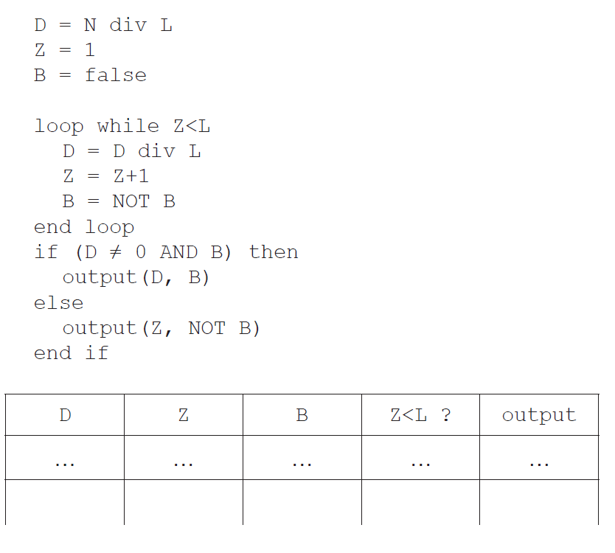

[4]

**Section B**

1. An examination office of a university must securely store students’ examination papers and

their grades. The office keeps the documentation of past students for two years. After two

years the office only stores the student grades. All documentation of current students is

frequently accessed for other operations and the volume of the data increases quickly.

To better support its operations, the office is creating a new system to provide this storage.

1. Identify **two** aspects of the data that need to be taken into account during the planning

of the new system. [2]

1. Describe how direct observations on the current system may provide information to

help propose a suitable new system. [3]

A prototype of the new system is created to present to the examination office.

1. Describe the purpose of this prototype. [3]

The examination office needs to upgrade the computing resources for their operations, and  
 this will require data migration.

1. Discuss **two** possible problems that may occur during data migration. [4]
2. Outline **one** economic aspect that the examination office needs to take into account to

support parallel running. [3]

1. A college has a high-speed network. The network is accessible to all students and staff

through their personal accounts.

The network may be accessed by using desktop computers available in the college. When

in the college, users can also use personal laptops to connect wirelessly or dock with an

Ethernet cable. When not in the college, users can connect via a virtual private network (VPN)

over the internet.

1. In the given context, distinguish between Ethernet and wireless in terms of **reliability**

of transmission. [4]

1. Describe **two** features of a VPN that make it secure. [4]
2. State one technology that is necessary for a VPN. [1]

The college is devising a policy for the use of its IT resources and services. They are  
 considering prohibiting the use of external services such as cloud storage and blogs.

1. In relation to the specific activities that may be carried out by students, discuss **two**

advantages and **two** disadvantages of the use of external services. [6]

1. A local charity organizes a half-marathon to raise money. The rules to participate in the

half-marathon are as follows:

* The organizers limit the total number of participants to 450
* Participants belong to a team and each team must have at least three and at most five
* participants
* Each participant registers for the event independently from the other members of their
* team, and they all declare their team name when registering
* For scoring, the team’s final time is the sum of the times of its three fastest participants.  
  Participants that do not cross the finishing line within 2 hours after the start, are assigned  
  a default time of 1000 minutes. The **winning team** is the team with the smallest sum total.

During registration, an array, PARTICIPANTS, with 450 positions is used to hold the

abbreviated team names that are declared by each participant. Simultaneously, a collection

TNAMES is generated: any new team name that is declared is added to the collection.

1. State the minimum size of TNAMES to ensure the names of all potential teams can

be stored. [1]

Part of the array PARTICIPANTS is shown below, where, for example, the first participant  
declared that they are part of team TK. The initial part of the collection TNAMES is also shown,  
with arrows indicating the direction of growth.

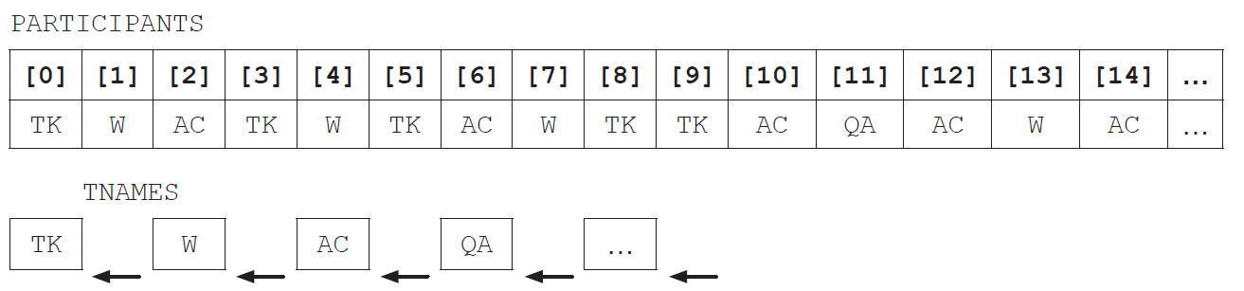

Both PARTICIPANTS and TNAMES are used to construct the array, TEAM, that groups all  
participants who belong to the same team. Part of the array TEAM is shown below.

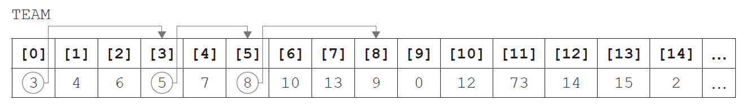

In TEAM, each element is related to one other index in the array, shown by the arrows on the  
above diagram. This relation will eventually form a closed path (for this example 0, 3, 5, 8, 9  
and back to 0). The relation reflects the information in PARTICIPANTS, by grouping people  
who declared the same team name during registration.

Hence, participants 0, 3, 5, 8 and 9 are on the same team and, from PARTICIPANTS, that team  
is TK.

1. Identify the position in PARTICIPANTS of the second participant that registered for

team QA. [1]

Part of the algorithm that generates the TEAM array is shown below, in pseudocode.

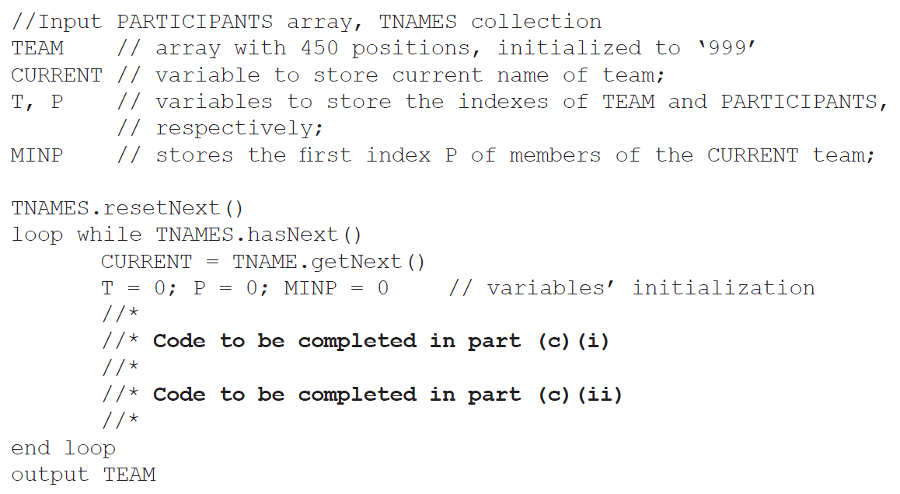

1. In order to complete this code, and return the correct TEAM array,
2. construct pseudocode to find MINP, the first index in PARTICIPANTS of the

CURRENT team, and use it to start the construction of TEAM [3]

1. construct pseudocode to find the other participants belonging to the CURRENT  
   team, implementing the idea of the closed paths in the TEAM array. [4]

As part of the program to determine the winning team, an array, TIMING, is maintained in  
parallel to PARTICIPANTS. For example, TIMING[5] and PARTICIPANTS[5] relate to the  
same participant.

TIMING is initialized to zero before the race starts, and updated with the finishing times for  
each participant. The algorithm sum3best is able to output the sum of the three fastest times  
from any group of times that are passed to the algorithm.

1. Describe the steps of an algorithm that will find the **winning team**, as defined by the

marathon rules on page 6. Clearly mention the use of existing or of new data structures. [6]